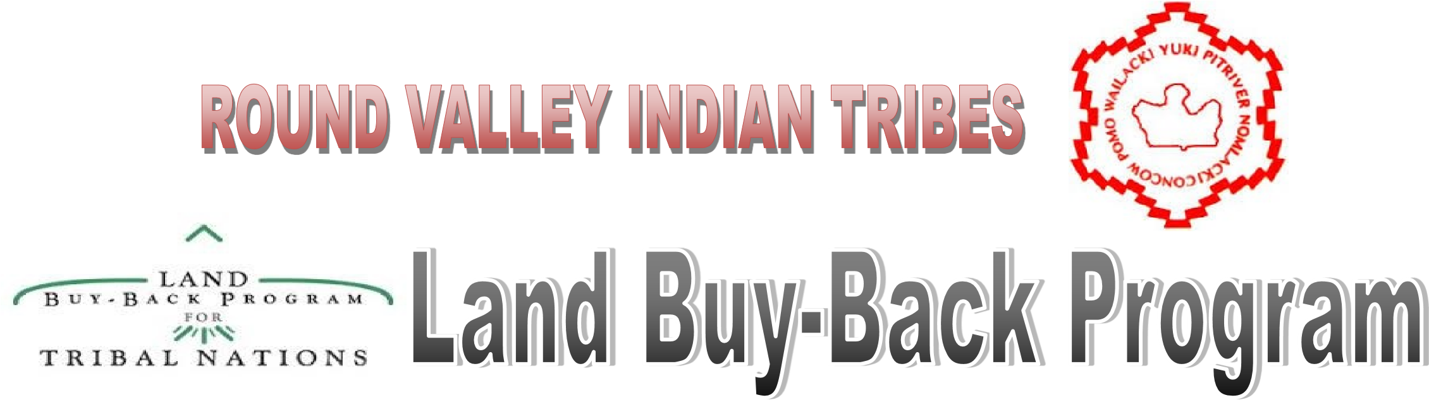
The Purchase Offer Outreach Workshops will be geared at assisting landowners with processing their purchase offer packets. Office of Special Trustees (OST) will be available at each workshop to print-out purchase offer-related documents, and Round Valley staff are providing FREE notary service. Also available at workshops: copiers, Round Valley main land tract map (numbered tracts), and FOOD.

DATE | TIME | LOCATION
6/2/16 | 12pm-4pm | UPPER LAKE, Running Creek Casino  Meeting Room, 635 State Hwy 20
6/3/16 | 12pm-4pm | SANTA ROSA, Sonoma County Indian Health  Community Meeting Rm, 144 Stony Point Rd
6/7/16 | 12pm-4pm | FORT BRAGG, Potter Valley Rancheria  Club House, 2801 State Hwy 1
6/14/16 | 12pm-4pm | LOLETA, Bear River Casino  Meeting Room, 27 Bear River Dr
6/15/16 | 12pm-4pm | REDDING, Win River Casino  Meeting Room, 2100 Redding Rancheria Rd
6/16/16 | 12pm-4pm | SACRAMENTO, BIA-Pacific Regional Office  Room #1003, 2800 Cottage Way
6/20/16 | 12pm-4pm | PALA, Pala Casino & Spa  Meeting Room, 11154 CA-76
6/21/16 | 12pm-4pm | LEMOORE, Tachi Palace Hotel & Casino  Salt Grass - 2nd Floor, 6835 Alkali Dr.
6/22/16 | 12pm-4pm | SAN FRANCISCO, Friendship House  Meeting Room, 56 Julian Ave
6/24/16 | 8am-7pm | COVELO, Round Valley Tribal Admin Bldg.  Buffalo Room, 77826 Covelo Rd

DATE | TIME | LOCATION
5/14/16 | 12pm-5pm | COVELO, Round Valley Tribal Admin Bldg.  Buffalo Room, 77826 Covelo Rd
5/19/16 | 11am-4pm | LAYTONVILLE, Cahto Rancheria Admin Bldg.  Meeting Room 300 Cahto Rd
5/20/16 | 11am-4pm | UKIAH, Coyote Valley Council Chambers  Next to Shodaki Casino, 7751 N State St
5/24/16 | 11am-4pm | JACKSON, Jackson Rancheria Hotel & Casino  Ballroom B, 12222 New York Ranch Road
5/25/16 | 11am-4pm | SACRAMENTO, BIA-Pacific Regional Office  Cafeteria Room #3, 2800 Cottage Way

LAND BUY-BACK STAFF:
Lynette Benton, Specialist – 707-354-5931
Renae Britton, Receptionist – 707-354-5843
Deborah Hutt, Director – 707-354-3917

TRUST BENEFICIARY CALL CENTER 888-678-6836
http://www.doi.gov/landbuyback

